Name:
In chapter 6, Uncle Axel explains his understanding of the geography of the world based on what he and other explorers have seen.
Assignment: create a map of the world according to a citizen of Waknuk as described in chapter 6. Show the approximate locations of cities, geographic areas, and populations.
Your map should include the following information:

Cities:
- Waknuk
- Rigo
- Lark
- The Old People’s Cities

Geographic Areas:
- Fringes
- Bad Lands
- Black Coasts
- Islands of Deviations (both north and south)
- Newf
- Straights of Newf

Deviations:
- 3 types of deviations, both Offences (plants and animals) and Blasphemies (people) are acceptable

Make sure to use colour, be as neat as possible, see that everything is labelled and strive for accuracy.
Here’s how your maps will be marked:

Accuracy /13
(All items included, appropriately located)

Clarity and Quality /7
(Evidence of strong effort, use of colour and effective design, easy to understand)

Total /20

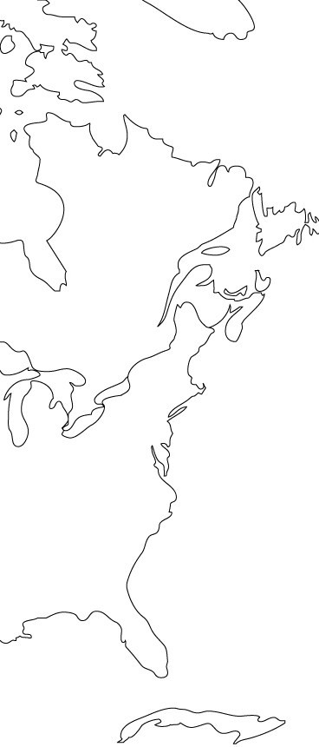
Examples of Deviations:
- Hairless people
- White hair and pink eyes (albinos?)
- Webbed fingers and toes
- Multi-breasted women (does multi = 2?)
- Thickset and thin
- Black people
- Monkeys
- Bigger sea creatures
Further south:
- Gold
- Silver
- Copper
- Spices
Black Coasts
- Nothing grows or lives here
- Old People’s Cities

Badlands
- Large plants (corn, saprophytes, fungus, succulents)
- Big flying creatures that don’t move like birds (planes?)

Newf
Fringes
Islands of Deviation (tall, strong women)
Lark
Straights of Newf
Waknuk
Rigo

