Effects of the Mongol Empire on Europe

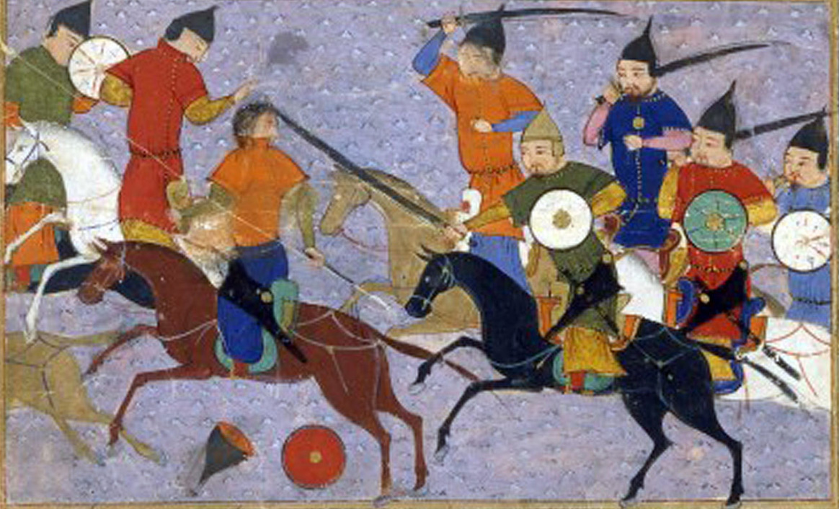

Heritage Images/Contributor/Getty Images
By Kallie Szczepanski
Updated August 02, 2019
In 1211, Genghis Khan (1167-1227) and his nomadic armies burst out from Mongolia and swiftly conquered most of Eurasia. The Great Khan died in 1227, but his sons and grandsons continued the expansion of the Mongol Empire across Central Asia, China, the Middle East, and into Europe.

Key Takeaways: Genghis Khan's Impact on Europe
- The spread of the bubonic plague from Central Asia into Europe decimated the populations but increased opportunities for the survivors.
- An enormous variety of new consumer goods, agriculture, weaponry, religion, and medical science became available in Europe.
- New diplomatic channels between Europe, Asia, and the Middle East were opened.
- Russia became unified for the first time.
Starting in 1236, Genghis Khan's third son, Ogodei, decided to conquer as much of Europe as he could. By 1240, the Mongols had control of what is now Russia and Ukraine, seizing Romania, Bulgaria, and Hungary over the next few years.
The Mongols also tried to capture Poland and Germany, but Ogodei's death in 1241 and the succession struggle that followed distracted them from this mission. In the end, the Mongols' Golden Horde ruled over a vast swath of eastern Europe, and rumors of their approach terrified western Europe, but they went no farther west than Hungary.
At their height, the rulers of the Mongol Empire conquered, occupied, and controlled more than twice the amount of land and twice the population as any other family in human history.
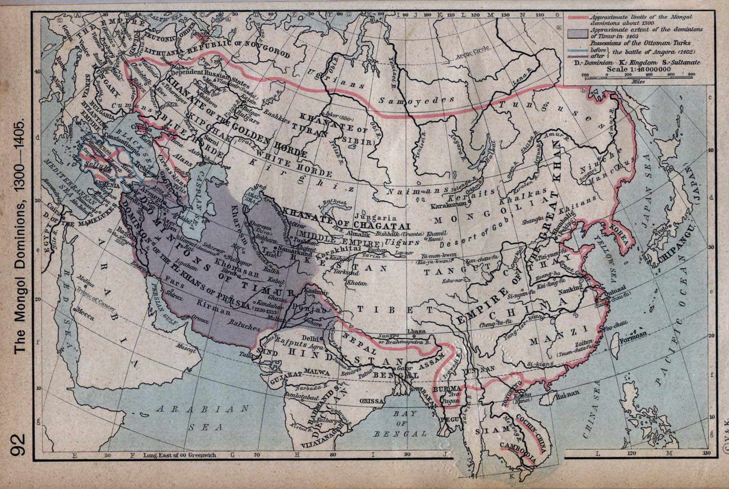
Shepherd, William. Historical Atlas. New York: Henry Holt and Company, 1911/Wikimedia Commons/Public Domain

The Mongol Invasion of Europe
Reports of the Mongol attacks terrified Europe. The Mongols increased their empire using swift and decisive attacks with an armed and disciplined cavalry. They wiped out the populations of some entire towns that resisted, as was their usual policy, depopulating some regions and confiscating the crops and livestock from others. This type of total warfare spread panic even among Europeans not directly affected by the Mongol onslaught and sent refugees fleeing westward.
Perhaps even more importantly, the Mongol conquest of central Asia and eastern Europe allowed a deadly disease — the bubonic plague — to travel from its home range in western China and Mongolia to Europe along newly-restored trade routes.
The bubonic plague was endemic to fleas that live on marmots in the steppes of eastern central Asia, and the Mongol hordes inadvertently brought those fleas across the continent, unleashing the plague on Europe. Between 1300 and 1400, the Black Death killed about 35 percent of China's people, its population dropping from 115 million to 75 million. In Europe, an estimated 25 percent of the people died, decreased the population from an estimated 79 million to 60 million.

Positive Effects of the Mongols
Although the Mongol invasion of Europe sparked terror and disease, in the long run, it had enormous positive impacts. The foremost was what historians call the Pax Mongolica, a century of peace (circa 1280-1360) among neighboring peoples who were all under Mongol rule. This peace allowed for the reopening of the Silk Road trading routes between China and Europe, increasing cultural exchange and wealth all along the trade paths.
Central Asia was a region that had always been important to overland trade between China and the West. As the region became stable under the Pax Mongolica, trade became less risky under the various empires, and as cross-cultural interactions became more and more intensive and extensive, more and more goods were traded.

Spread of Technology
Within the Pax Mongolica, the sharing of knowledge, information, and cultural identity was encouraged. Citizens could legally become followers of Islam, Christianity, Buddhism, Taoism, or anything else — as long as their practice didn't interfere with the political ambitions of the Khan. The Pax Mongolica also allowed monks, missionaries, traders, and explorers to travel along the trade routes. One famous example is the Venetian trader and explorer Marco Polo, who traveled to the court of Genghis Khan's grandson Kublai Khan (Quibilai) at Xanadu in China.
Some of the most fundamental ideas and technologies in the world — papermaking, printing, and gunpowder manufacturing, among many others — made their way across Asia via the Silk Road. Migrants, merchants, explorers, pilgrims, refugees, and soldiers brought along with them their disparate religious and cultural ideas and domesticated animals, plants, flowers, vegetables, and fruit as they joined this gigantic cross-continental exchange. As historian Ma Debin describes it, the Silk Road was the original melting pot, the lifeline of the Eurasian continent.

Effects of the Mongol Conquest
Before the Mongol Empire, Europeans and Chinese were largely unaware of the other's existence. Trade established along the Silk Road in the first centuries B.C.E. had become rare, dangerous, and unpredictable. Long-distance trade, human migration, and imperial expansion actively engaged people in different societies in significant cross-cultural interactions. Afterward, interactions between the two were not only possible but encouraged.
Diplomatic contacts and religious missions were established over vast distances. Islamic merchants helped gain a footing for their faith at the extreme ends of the Eastern Hemisphere, spreading from southeast Asia and west Africa and across northern India and Anatolia.
Alarmed, western Europeans and the Mongol rulers of China sought a diplomatic alliance with one another against the Muslims in southwest Asia. Europeans sought to convert Mongols to Christianity and establish a Christian community in China. The Mongols saw the spread as a threat. Neither of these initiatives was successful, but the opening of political channels made a substantive difference.

Transfer of Scientific Knowledge
The entire overland route of the Silk Road witnessed a vigorous revival under the Pax Mongolica. Its rulers actively worked to ensure the safety of the trade routes, building effective post stations and rest stops, introducing the use of paper money and eliminating artificial trade barriers. By 1257, Chinese raw silk appeared in the silk-producing area of Italy, and in the 1330s, a single merchant sold thousands of pounds of silk in Genoa.
The Mongolians absorbed scientific knowledge from Persia, India, China, and Arabia. Medicine became one of the many areas of life and culture that flourished under Mongol rule. Keeping an army healthy was vital, so they created hospitals and training centers to encourage the exchange and expansion of medical knowledge. As a result, China employed doctors from India and the Middle East, all of which was communicated to European centers. Kublai Khan founded an institution for the study of Western medicine. The Persian historian Rashid al-Din (1247-1318) published the first known book on Chinese medicine outside China in 1313.

Unification of Russia
The Golden Horde's occupation of eastern Europe also unified Russia. Prior to the period of Mongol rule, the Russian people were organized into a series of small self-governing city-states, the most notable being Kiev.
In order to throw off the Mongol yoke, the Russian-speaking peoples of the region had to unite. In 1480, the Russians — led by the Grand Duchy of Moscow (Muscovy) — managed to defeat and expel the Mongols. Although Russia has since been invaded several times by the likes of Napoleon Bonaparte and the German Nazis, it has never again been conquered.

The Beginnings of Modern Fighting Tactics
One final contribution that the Mongols made to Europe is difficult to categorize as good or bad. The Mongols introduced two deadly Chinese inventions — guns and gunpowder — to the West.
The new weaponry sparked a revolution in European fighting tactics, and the many warring states of Europe all strove over the following centuries to improve their firearms technology. It was a constant, multisided arms race, which heralded the end of knightly combat and the beginning of modern standing armies.
In the centuries to come, European states would muster their new and improved guns first for piracy, to seize control over parts of the oceangoing silk and spices trade, and then eventually to impose European colonial rule over much of the world.
Ironically, the Russians used their superior firepower in the 19th and 20th centuries to conquer many of the lands that had been part of the Mongol Empire, including outer Mongolia where Genghis Khan was born.

Sources
Bentley, Jerry H. "Cross-Cultural Interaction and Periodization in World History." The American Historical Review, Vol. 101, No. 3, Oxford University Press, JSTOR, June 1996.
Davis-Kimball, Jeannine. "Asia, Central, Steppes." Encyclopedia of Archaeology, Academic Press, ScienceDirect, 2008.
Di Cosmo, Nicola. "Black Sea Emporia and the Mongol Empire: A Reassessment of the Pax Mongolica." Journal of the Economic and Social History of the Orient, Volume 53: Issue 1-2, Brill, January 1, 2009.
Flynn, Dennis O. (Editor). "Pacific Centuries: Pacific and Pacific Rim Economic History since the 16th Century." Routledge Explorations in Economic History, Lionel Frost (Editor), A.J.H. Latham (Editor), 1st Edition, Routledge, February 10, 1999.
Ma, Debin. "The Great Silk Exchange: How the World Was Connected and Developed." CiteSeer, The College of Information Sciences and Technology, The Pennsylvania State University, 2019.
Pederson, Neil. "Pluvials, droughts, the Mongol Empire, and modern Mongolia." Amy E. Hessl, Nachin Baatarbileg, et al., Proceedings of the National Academy of Sciences of the United States of America, March 25, 2014.
Perdue, Peter C. "Boundaries, Maps, and Movement: Chinese, Russian, and Mongolian Empires in Early Modern Central Eurasia." Volume 20, 1998 - Issue 2, The International History Review, Informa UK Limited, December 1, 2010.
Safavi-Abbasi, S. "The fate of medical knowledge and the neurosciences during the time of Genghis Khan and the Mongolian Empire." Neurosurg Focus, Brasiliense LB, Workman RK, et al., National Center for Biotechnology Information, U.S. National Library of Medicine, 2007, Bethesda MD.

